Jacob Smith 2/27/2020 1:51 PM: I have decided to make this my main Impact Maker Notebook for Brandeis RTI because this is the repository where I put most of the work for that role and the Class generator is now a SPARK Project. See [here](https://github.com/jsmith2021Brandeis/Arduino_Arduino_Class_Maker/tree/master/documentation) for old notebook.

I am updating the Arduino workshop with examples [code](https://www.instructables.com/id/Arduino-37-in-1-Sensors-Kit-Explained/) [wiring diagrams](https://images-eu.ssl-images-amazon.com/images/I/C1lrpIfADaS.pdf) [tutoria](https://www.hobbytronics.co.za/Content/external/1082/37-in-1%20Sensor%20Kit%20Guide_compressed%20(1).pdf)l

Temperature step 12

See this note on slides from Waltham teacher

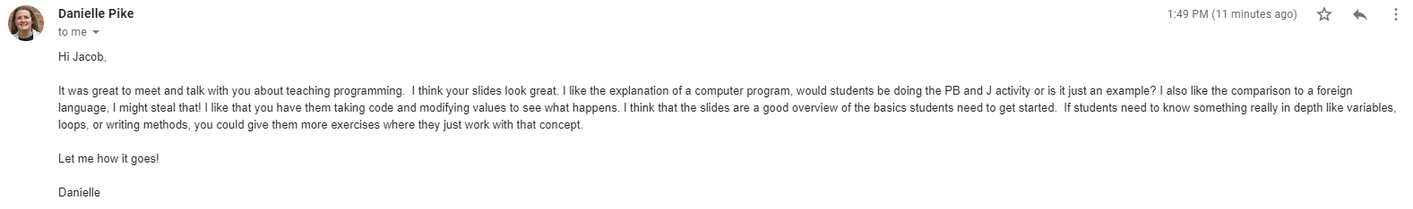

3/9/2020 12:15 AM: [Force Sensitive Resistor Example](https://learn.adafruit.com/force-sensitive-resistor-fsr/using-an-fsr) works

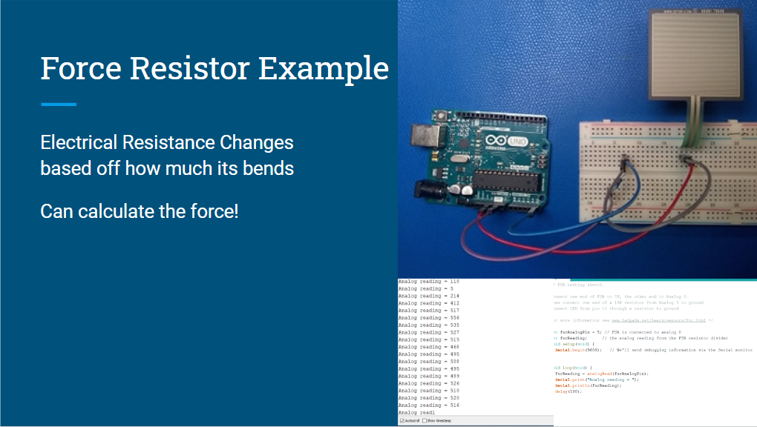

[Pushbutton Example Works](https://www.arduino.cc/en/tutorial/pushbutton)

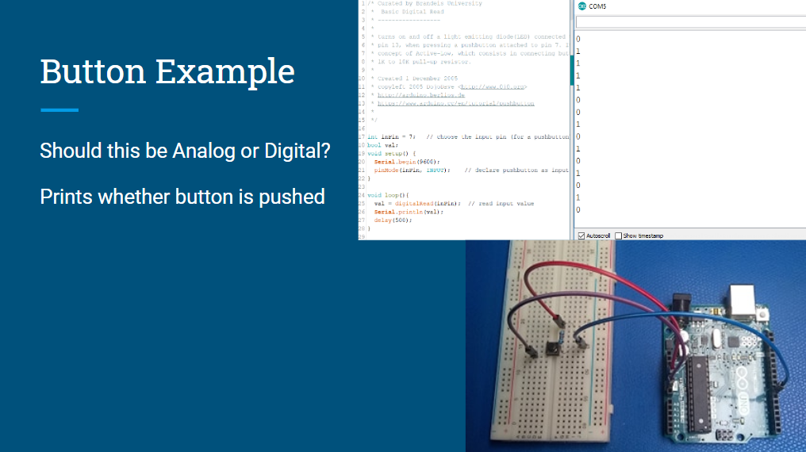

Added Zumo Example, which created dependency with Zumo shield library.

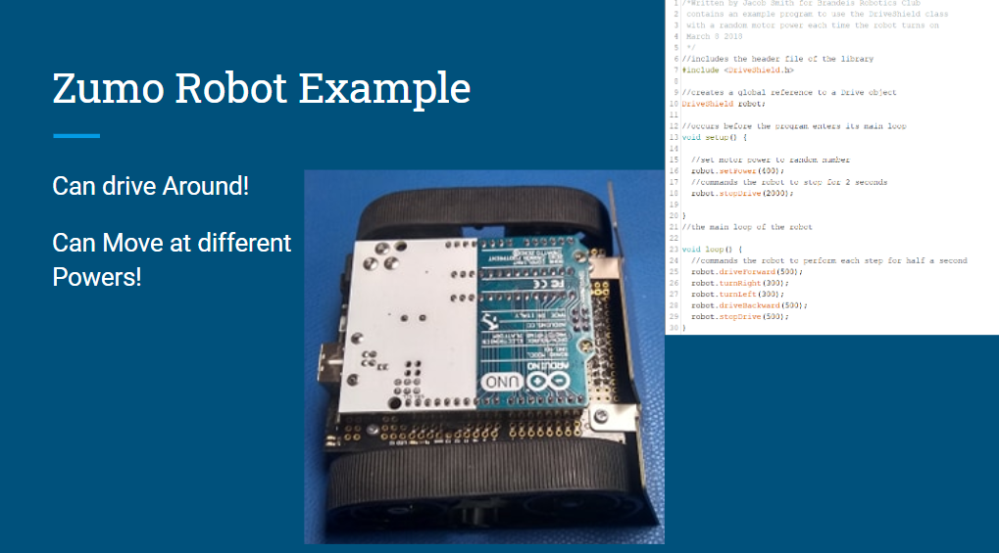

4/10/20 11:39 PM: While using new sensors in my guide for COVID virtual classes, I found that the Arduino tone method uses the same timer as the infrared sensor. I will use [this example code](https://arduino.stackexchange.com/questions/33137/how-to-fix-compilation-error-for-tone-using-same-timer-as-other-function) as the newbuzzer code because it uses PWM instead of timers so can be used with sensors that have timers.

5/8/2020 3:18 PM. Jacob Smith Arduino software research: [This](https://github.com/arduino/EduIntro) repository from Arduino is similar to the Brandeis Education repository. I found the [original issue request](https://github.com/arduino/Arduino/issues/9042) to add this repository.